MEHRAN UNIVERSITY

OF ENGINEERING & TECHNOLOGY

JAMSHORO, PAKISTAN

Subject: Software Construction and Development

(Lab 4 - Tasks Solution)

|  |  |
| --- | --- |
| **Roll No:** | **22SW028** |
| **Section:** | **I** |
| **Name** | **Arbab Hussain** |

**LAB 04 TASKS (Selenium IDE)**

**Install Selenium and Perform a Test Case with it.**

**Solution:**

**Step1: Open Firefox Web Browser**

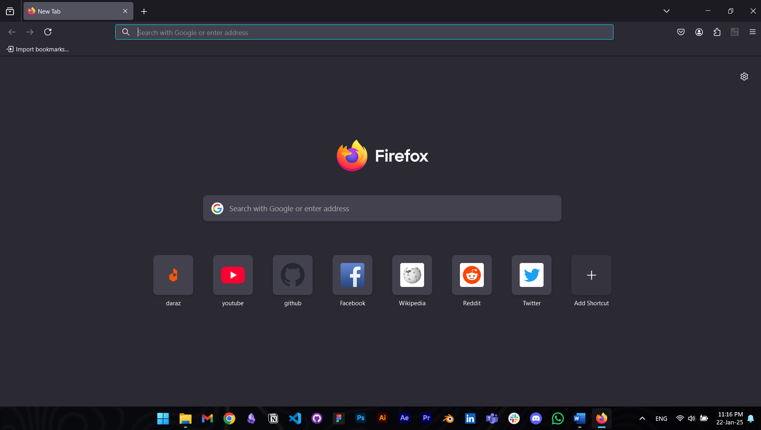

**Step 2: Download Selenium IDE extension from Mozilla AddOns**

**Step 3: After Installation, the selenium icon would be shown on the top of Firefox, click on it to open Selenium IDE.**

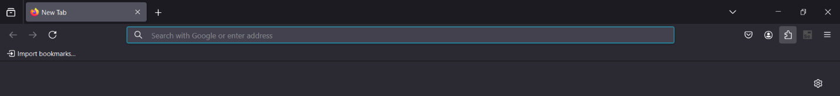

**Step 4: Click on Create a New Project and Name it as per your choice:**

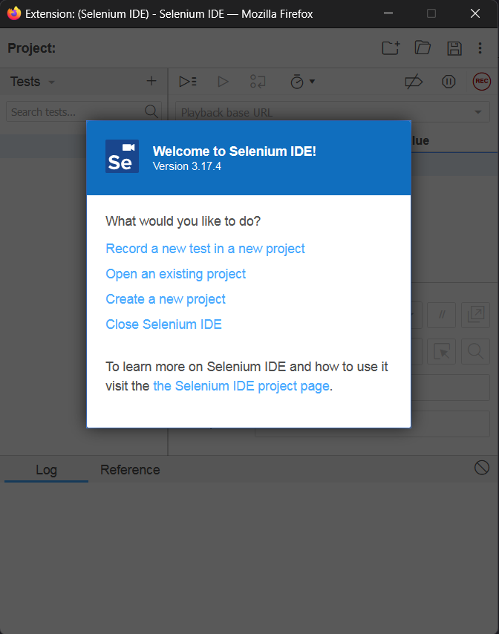

**Step 5: Click on The record button shown on the top bar of Selenium and put the URL of the website/webapp you want to test:**

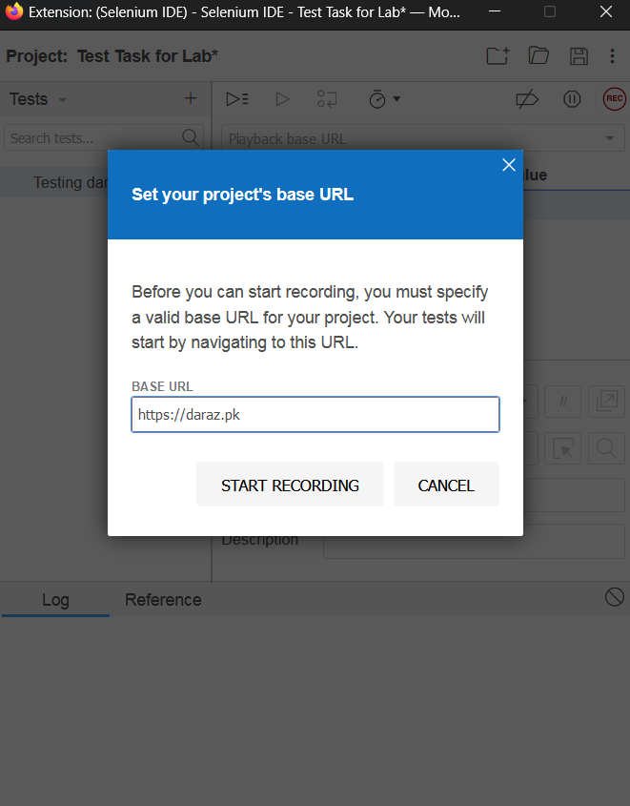

**Step 6: Click on Start Recording, It will open up the website in a new window where you can use it to test its features.**

**After you’re done, you can click on the same record button again to stop recording it**

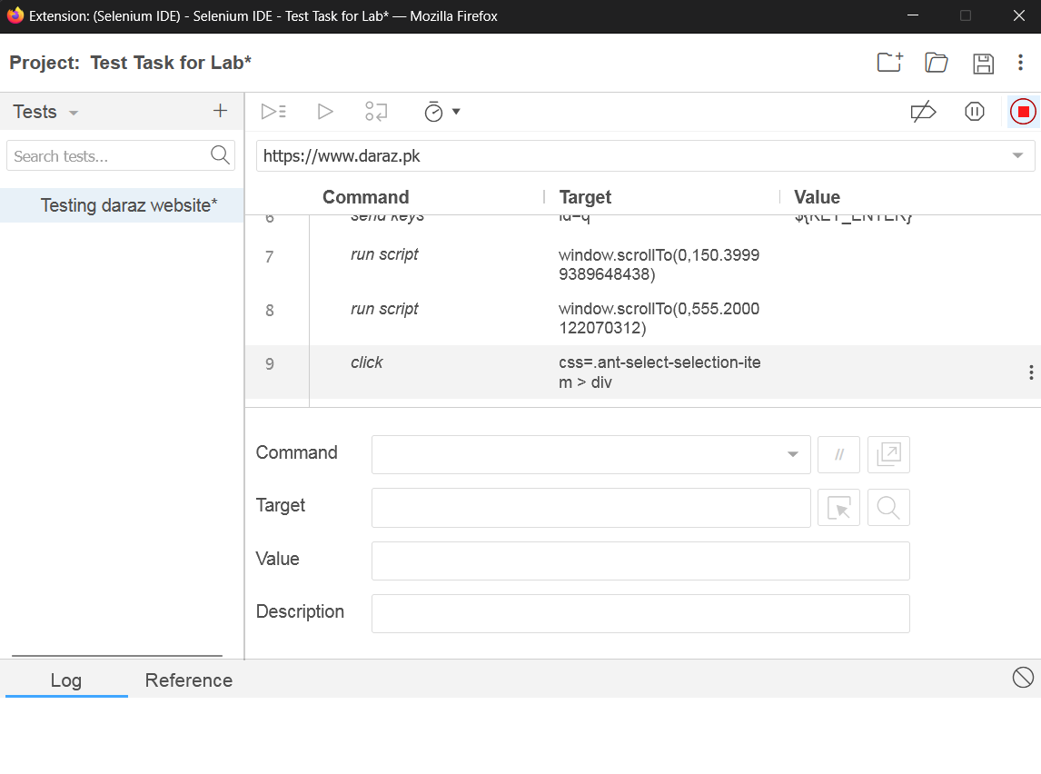

**Step 7:**

**You can run this test case by clicking on “Run Current Test Case Button”. It will open up a new window again and perform all your actions.**

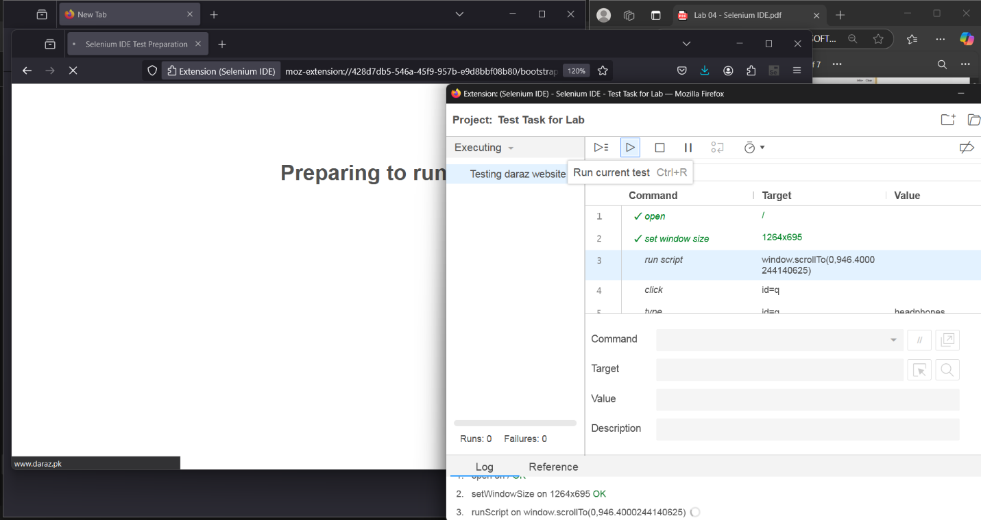

**Step 8: You can save this test case as unit testing files of C#, Java, Js, Python and Ruby. For this task, we’re saving it in a file of C# NUnit.**

* **Right Click on the Test’s name and click on Export.**

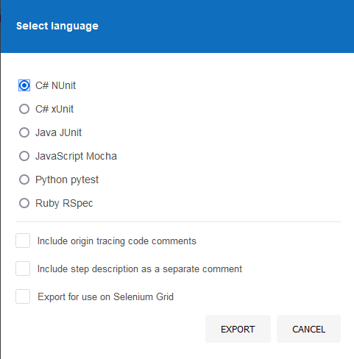

**After exporting, You can later on open this in any code editor of your choice.**